Eyeconic - Glasses Shop Management System

Use-Case Specification: M02 - Remove User

Version 1.0

Revision History

|  |  |  |  |
| --- | --- | --- | --- |
| **Date** | **Version** | **Description** | **Author** |
| 05/11/2019 | 1.0 | Start creating use case | Hoàng Tiến Long |
|  |  |  |  |
|  |  |  |  |
|  |  |  |  |

Table of Contents

1. Remove User 4

1.1 Brief Description 4

1.2 Actor 4

2. Flow of Events 4

2.1 Basic Flow 4

2.2 Exception 4

2.2.1 Remove user 4

3. Special Requirements 4

4. Preconditions 5

4.1 Login 5

5. Postconditions 5

6. Extension Points 5

# Remove User

## Brief Description

This use cacse defines the step of deleting user.

Users are deleted by the admin.

## Actor

Administrator.

# Flow of Events

## Basic Flow

In user management, the system administration clicks the remove button management user. The confirmation dialog show case. The system displays the updated management parameter value and logs the change.

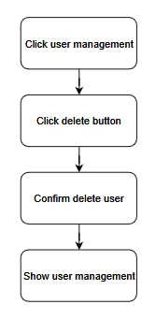

***Basic flow of removing order***

Step 1: Click management user.

Step 2: Click delete button.

Step 3: Confirm removing new user.

Step 4: Display user management.

## Exception

### Remove user

The remove button cannot be clicked or isn’t appeared on the screen.

# Special Requirements

No Special Requirements

# Preconditions

## Login

Actor must already login as the administrator of the website

Accuracy is required when administrator want to remove user.

# Postconditions

# Extension Points

No extension points.